|  |  |  |  |  |  |
| --- | --- | --- | --- | --- | --- |
| Date | 6-Dec-22 | | | Tester Name | Richard Belanger |
| Environment | Penfax - Test | | | Login used | TEST2 |
| Operating System | Windows | Version: | Update: | | |
| Software Used | Edge | Version: | Update: | | |
| Not Applicable | Version: | Update: | | |
| Release version | 22.4.1 | | | | |
| Title | M13.03 Member with different beneficiaries - Single member | | | | |
| Test Type | Regression | | | | |
| Test Scenario | Calculate benefits for Deferred member death | | | | |
|  |  | | | | |
| Expected Results | Member will be Terminated after Death and payment produced | | | | |
| Pass/Fail | Pass | | | JIRA# | N/A |

Describe your steps with screenshots:

Single Deferred member with two beneficiaries dies

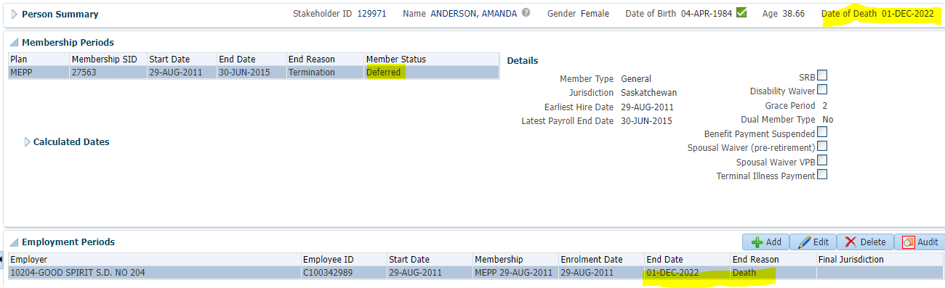

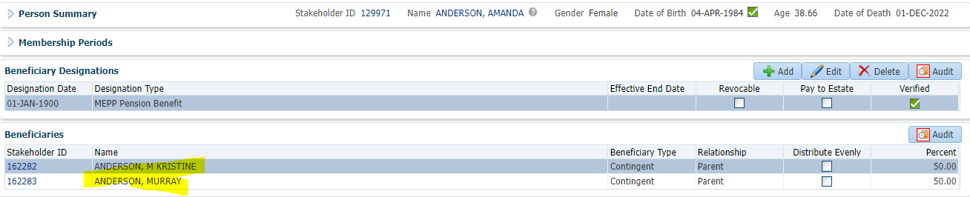

Benefit Calculation>Calculate

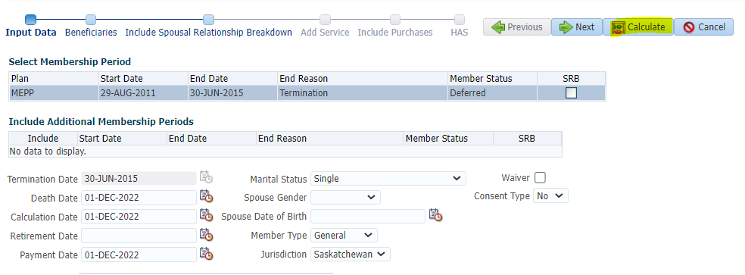

Processed>To Benefit Selection

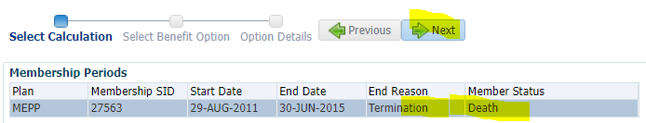

Add Payment date>Next

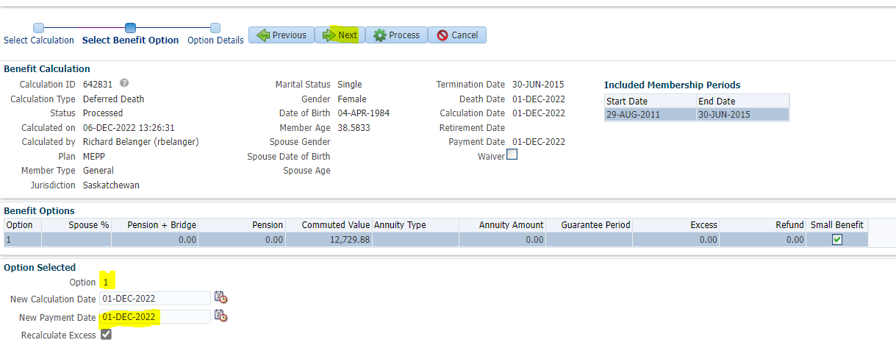

Choose Option and Payment Instructions>Process

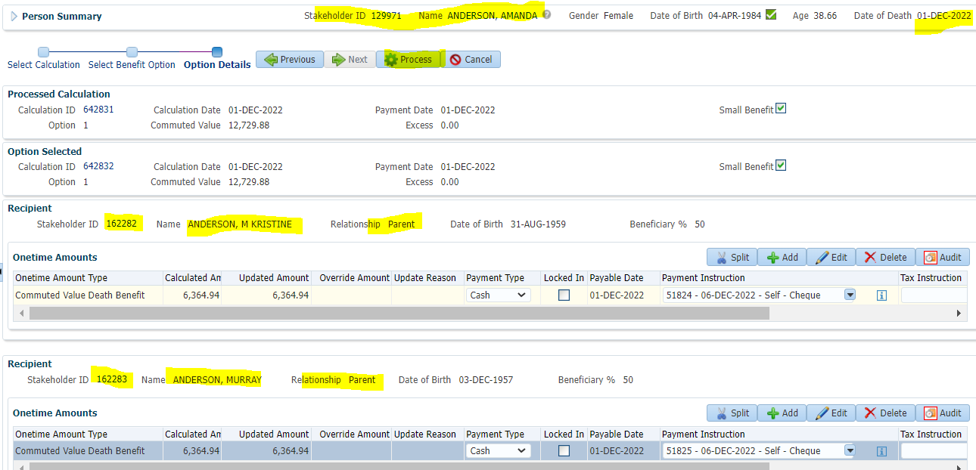

Processed to Beneficiaries’ Benefit Recipient>Submit for Approval>Submit both payments

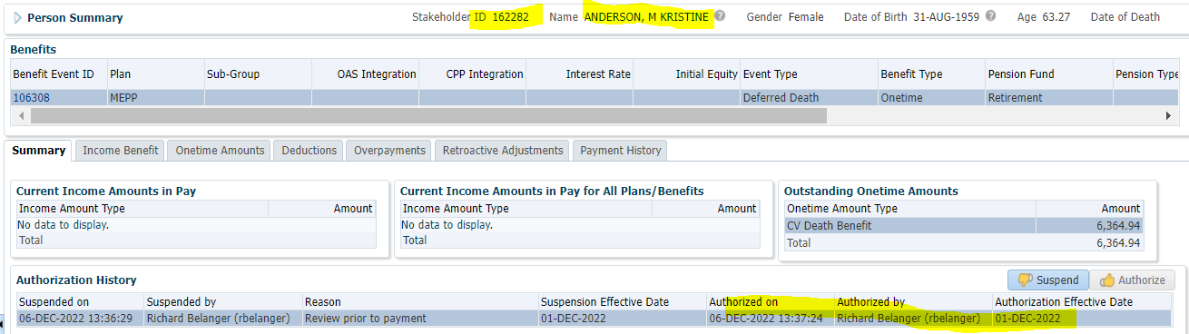

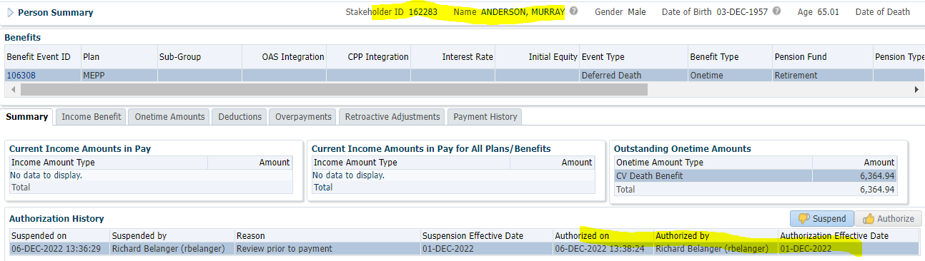

Beneficiaries both took Cash

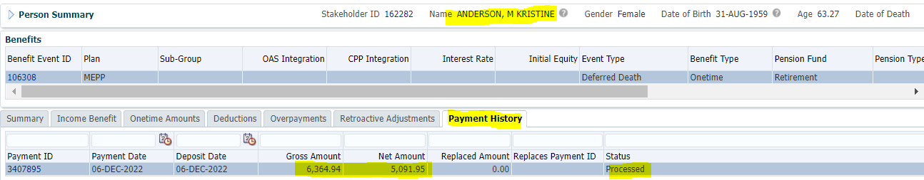

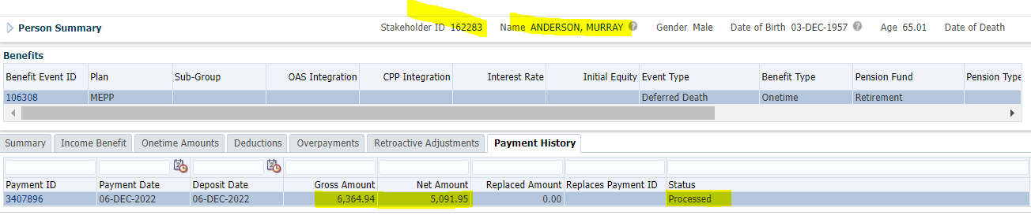

Tax Rates

0.00-4,999.99 = 10%

5,000.00- 14,999.99 = 20%

15,000.00+ = 30%

Both payments amount to 6364.94(Gross)

6364.94 x 20% = 1,272.99; 6364.94 – 1272.99 = **$5,091.95**